CEG 4750/6750 Information Security

Lab/Project 2
Using AES Algorithm

A project submitted in partial fulfillment of the requirements for the
CEG 4750/6750 Information Security

By
Bhuwan Pandey (U01155118)
Bipin Poudel (U01151906)

To
Prof. Meilin Liu

04/03/2026

WRIGHT STATE UNIVERSITY

Introduction
In this project, the AES encryption/decryption programs are provided, and the students (we) will compile and run these programs to encrypt/decrypt files on fry.cs.wright.edu. The AES encryption/decryption programs used an existing crypto library, Crypto++ (C++), which was installed on fry.cs.wright.edu.
For the project, the very first thing we did was to connect to fry.cs.wright.edu and access the shell to do the work. To keep things simple, we created directory named Project 2, copied files into the folder and began working under the directory.
As per the instruction provided and for our own ease, we created an alias called cryptog++ for the command as shown in the Figure 1.1 below. This helped us avoiding typing such a long command each time we try to compile our program.
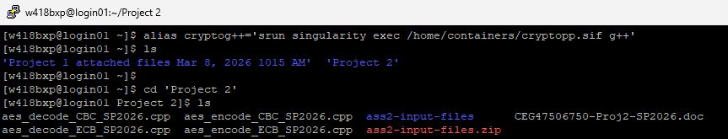
Figure 1.1 – Alias
Also as demonstrated in the below Figure 1.2, we can see that the alias is working perfectly as the compilation of both the encryption/decryption program works. The encryption and decryption programs are named Task1CbcEnc and Task1CbcDec respectively.
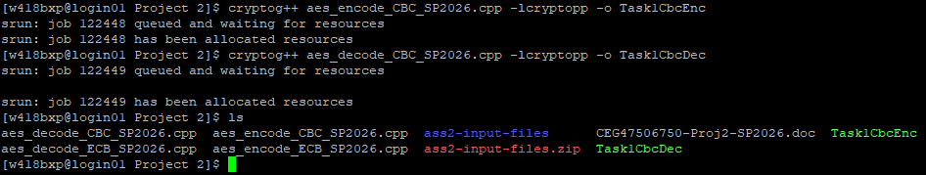
Figure 1.2 – Compilation
Now, we begin along with the task that we are supposed to complete.

Task 1
For Task 1 and Task 2, we are required to compile and execute the provided source AES encryption/decryption programs in CBC and Counter mode respectively, and verify the decrypted file is identical to the original plaintext file. There are total of 4 test files provided to us for the task, which are MSG1, MSG2, MSG3, and text1. And for each file, we are required to do the following:
- Encrypt the file to output it suffixed with .e to indicate it as an encrypted file.
- Decrypt the file to output it suffixed with .d to indicate it as a decrypted file.
- Compare the bytes of couple of encrypted files.
- Show the difference between two files (the original and the decrypted) to demonstrate the working nature of overall process.
For the subtasks requested, we began encrypting each of the input files one by one as shown in the Figure 1.3 below.
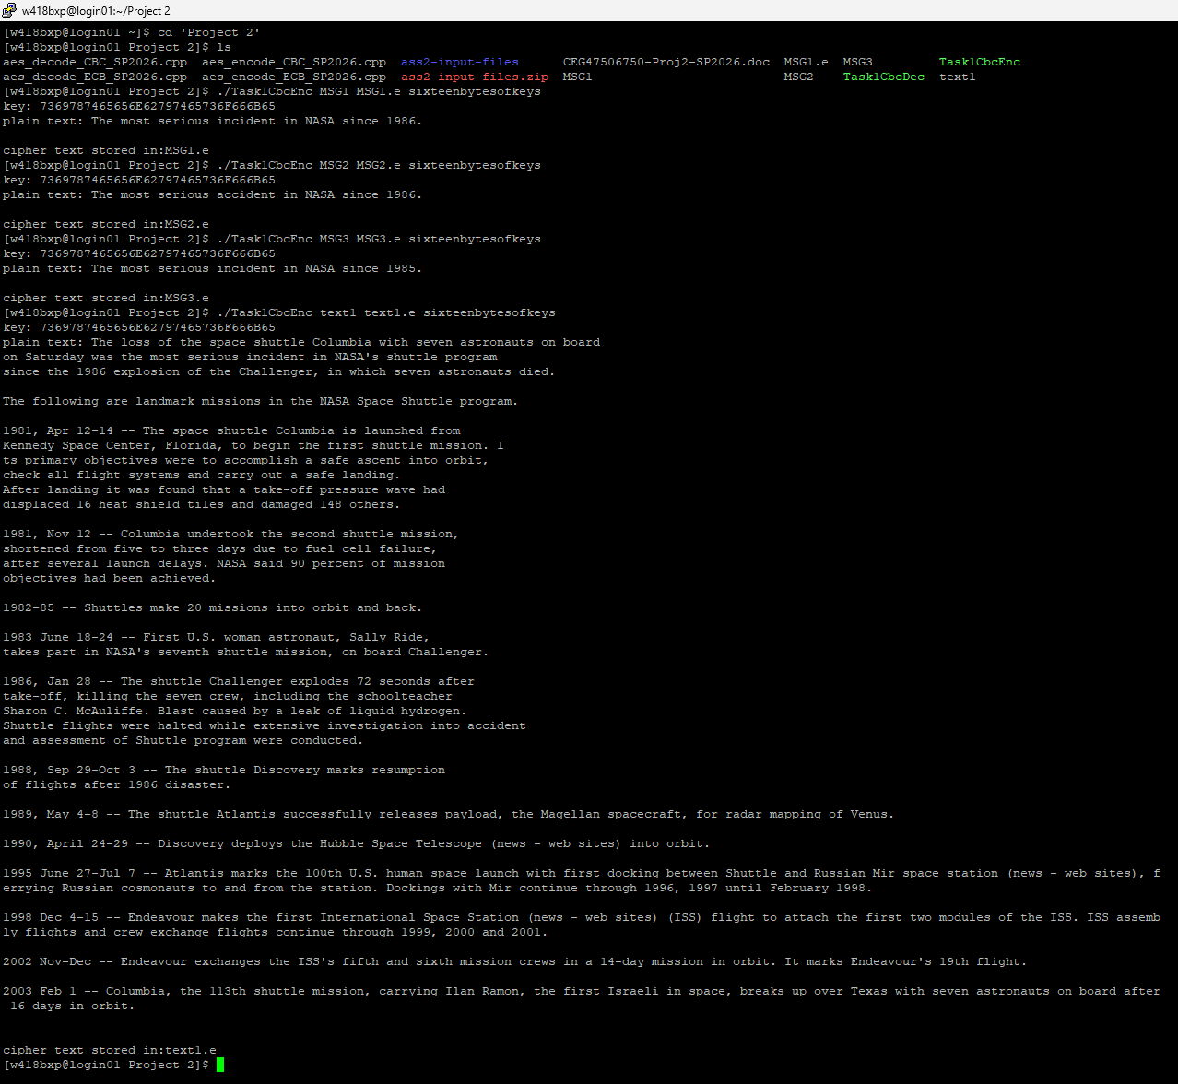
Figure 1.3 – Encryption of input files
Similarly, we tried decrypting the encrypted files as shown in the following Figure 1.4 and Figure 1.5.
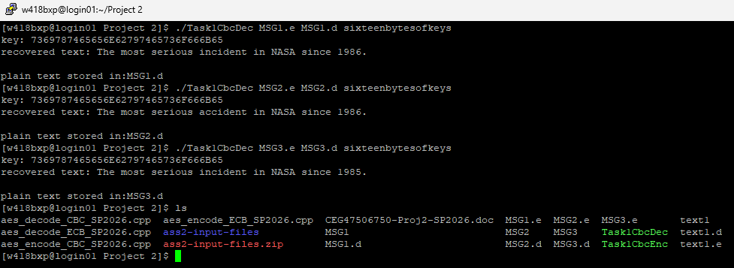
Figure 1.4 – Decryption of encrypted files

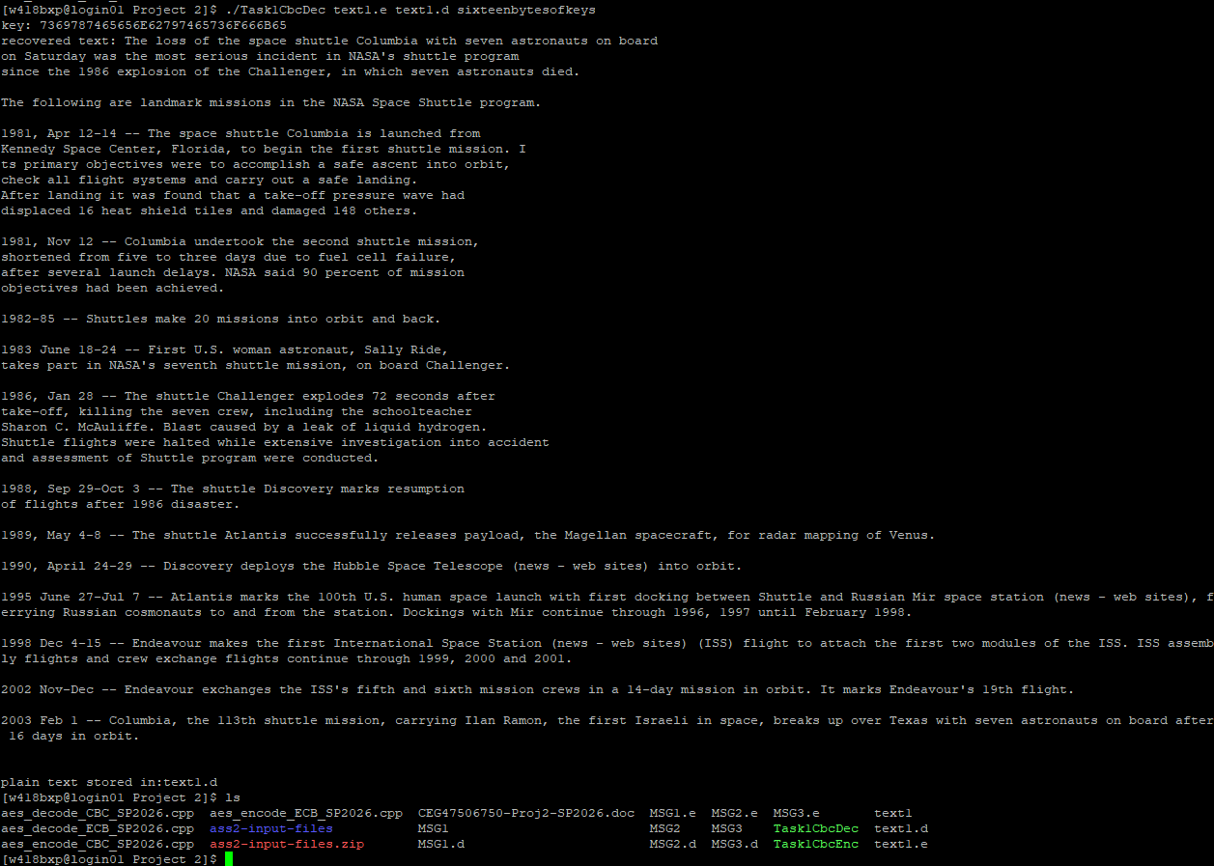
Figure 1.5 – Decryption of encrypted files

Task 1.1
So far, so good. For the subtask 1.1, we print the octal byte values using the command od –b filename for each file as shown in the below Figure 1.1.1.
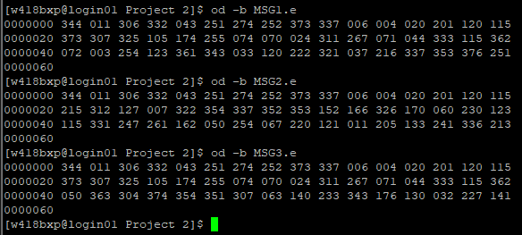
Figure 1.1.1 – Octal byte values of encrypted files

Task 1.2
From the above Figure 1.1.1, we can conclude for the comparison of MSG1.e and MSG2.e, the first 16 bytes (first two rows) are completely identical. The difference begins at byte 16 (offset 0000020) and continues through the remaining bytes. This indicates that the first AES block (16 bytes) is identical in both ciphertexts, while subsequent blocks differ.
Similarly, for MSG1.e and MSG3.e, the first two rows (first 32 bytes) are identical and the difference only starts at byte 32 (offset 0000040), meaning the first two AES blocks (32 bytes) are identical, with differences beginning at the third block.
This overall difference is actually expected with AES-CBC mode as messages share common prefixes and is 16 of bytes.

Task 1.3
We are required to use diff command to show the difference of two files (the original file, and the decrypted file). The result is shown in the Figure 1.3.1 below:
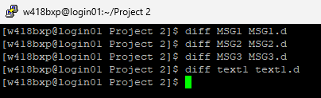
Figure 1.3.1 – Difference between files
We can observe from the above Figure 1.3.1, we can clearly conclude that the encryption and decryption works perfectly as there are no differences shown for all the comparisons made.
As we have noticed already, the CBC mode requires an initialization vector (IV) to encrypt and decrypt a file where the size of the IV is set to the AES’s default length. i.e. 16 bytes typically. The source code for both the files are provided in below Figure 1.6 and Figure 1.7.
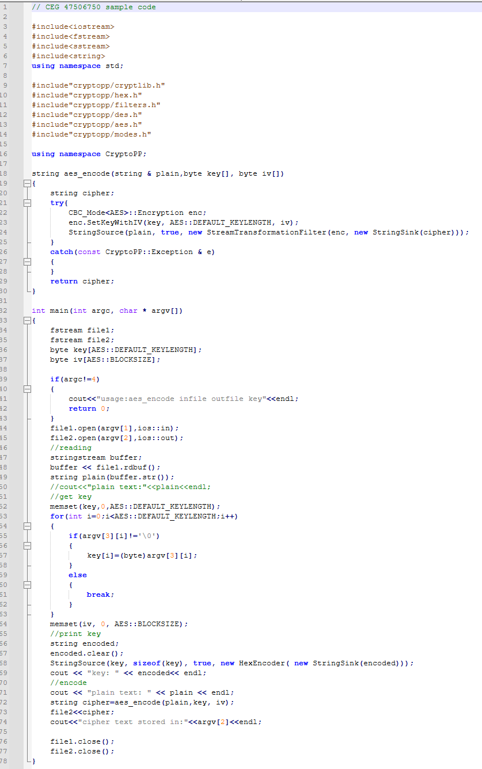
Figure 1.6 – Source code (aes_encode_CBC_SP2026.cpp)
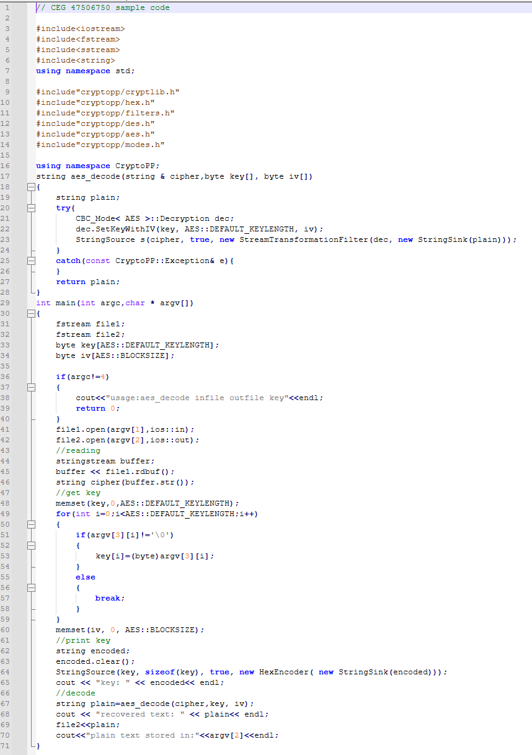
Figure 1.7 – Source code (aes_decode_CBC_SP2026.cpp)

Task 2
For this task, we are provided with the source AES encryption/decryption programs that performs in Counter mode. We are required to change the source code files of the AES programs, so that the programs are working in Counter mode while still verifying that the decrypted file is identical to its original plaintext file.
This task in Counter mode, requires us to do perform the same type of operations as in Task 1. Meaning, we are required to encrypt and decrypt the files (with .ee and .dd suffix for encryption and decryption respectively), show the byte difference between MSG1.ee and MSG2.ee, MSG1.ee and MSG3.ee, and check the integrity with diff command for the input files and their respective decrypted ones.
As shown in below Figure 2.1, the encryption and decryption programs are named Task2CounterEnc and Task2CounterDec respectively.
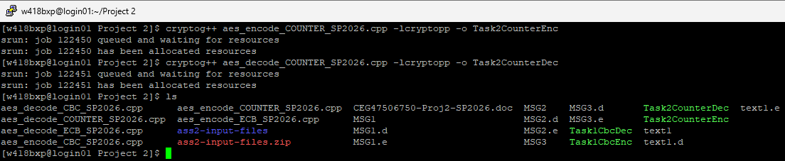
Figure 2.1 – Compilation
For the subtasks requested, we began encrypting each of the input files one by one as shown in the Figure 2.2 and Figure 2.3 below.
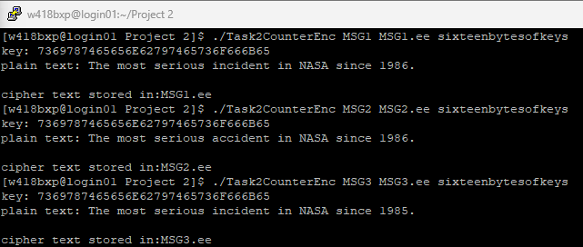
Figure 2.2 – Encryption of input files

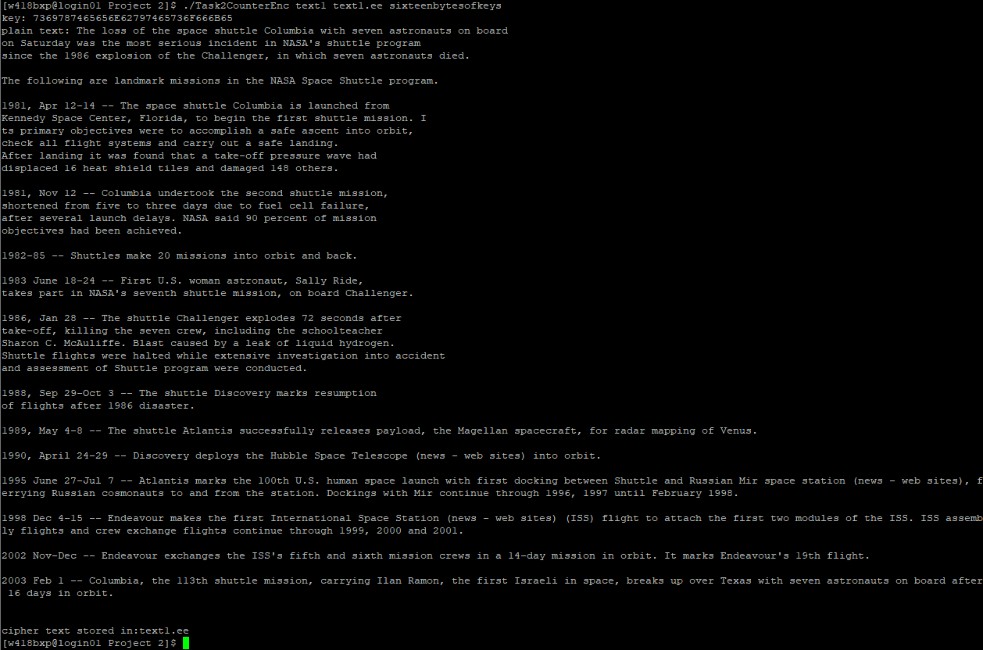
Figure 2.3 – Encryption of input files
The below Figure 2.4 with ls command shows that the above operations were executed successfully.
Figure 2.4 – List of files
Similarly, we tried decrypting the encrypted files as shown in the following Figure 2.5 and Figure 2.6.
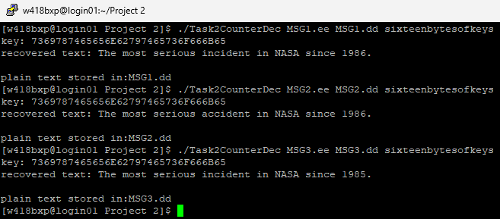
Figure 2.5 – Decryption of encrypted files

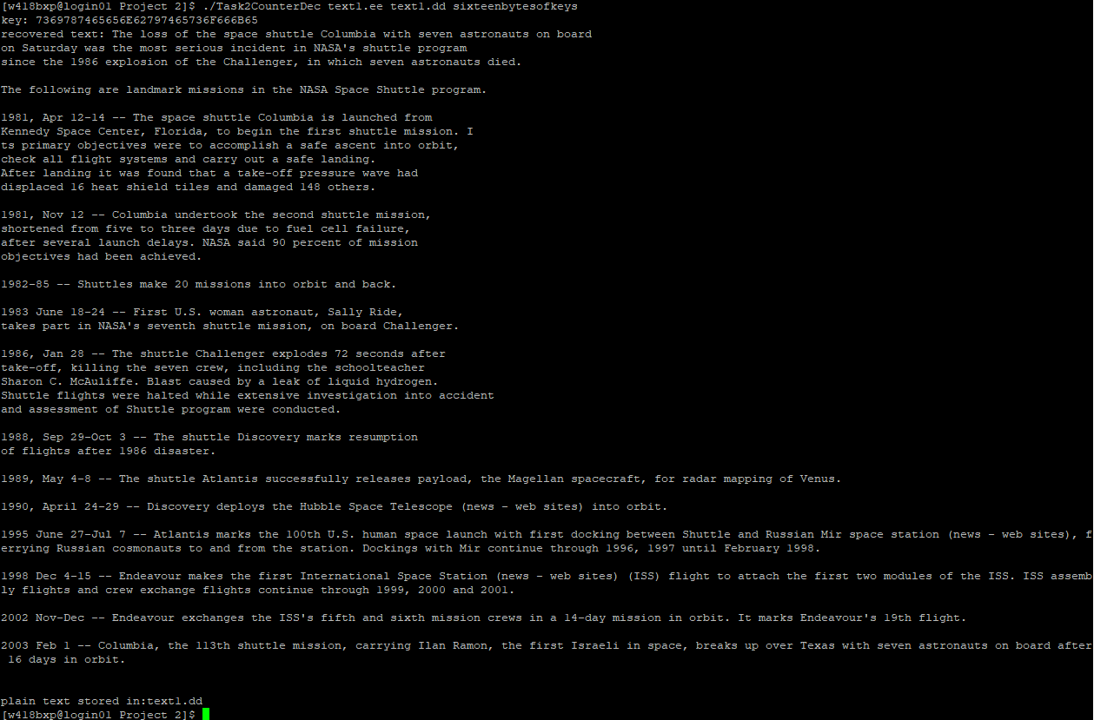
Figure 2.6 – Decryption of encrypted files
The below Figure 2.7 shows with the ls command, the decrypted files (with .ee suffix), denoting that the decryption was successful.
Figure 2.7 – List of files

Task 2.1
So far, so good. For the subtask 2.1, we print the octal byte values using the command od –b filename for each file as shown in the below Figure 2.1.1.
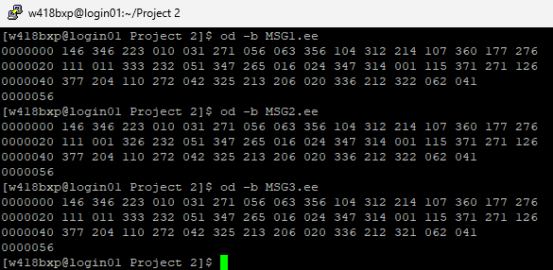
Figure 2.1.1 – Octal byte values of encrypted files

Task 2.2
From the above Figure 2.1.1, we can conclude for the comparison of MSG1.ee and MSG2.ee, the first 16 bytes (first row) are completely identical. At offset 0000020, the second byte of the second row shows the first difference, where MSG1.ee has 333 and MSG2.ee has 326, with subsequent bytes continuing to differ throughout.
For the comparison of MSG1.ee and MSG3.ee, the first 32 bytes (first two rows) are completely identical, with the only difference occurring at the third-last byte of the third row (offset 0000040 + 12), where MSG1.ee has 322 and MSG3.ee has 321.
This behavior is characteristic of AES-CTR mode, where ciphertext differences localize precisely to positions where plaintext differs. CTR mode transforms AES into a stream cipher by XORing plaintext with a keystream generated from successive counter values, ensuring byte level isolation of changes. Here, MSG1.ee and MSG3.ee differ by only one byte, indicating nearly identical plaintexts, while the differences between MSG1.ee and MSG2.ee begin at byte 17 and propagate from there, reflecting multiple plaintext variations from that position onward. Unlike ECB or CBC where changes ripple across entire blocks, CTR mode isolates differences with exact byte-level precision.

Task 2.3
We are required to use diff command to show the difference of two files (the original file, and the decrypted file). The result is shown in the Figure 2.3.1 below:
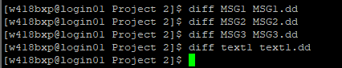
Figure 2.3.1 – Difference between files
We can observe from the above Figure 2.3.1, we can clearly conclude that the encryption and decryption works perfectly as there are no differences shown for all the comparisons made.
As we have noticed already, the CBC mode requires an initialization vector (IV) to encrypt and decrypt a file where the size of the IV is set to the AES’s default length. i.e. 16 bytes typically. The source code for both the files are provided in below Figure 2.6 and Figure 2.7.
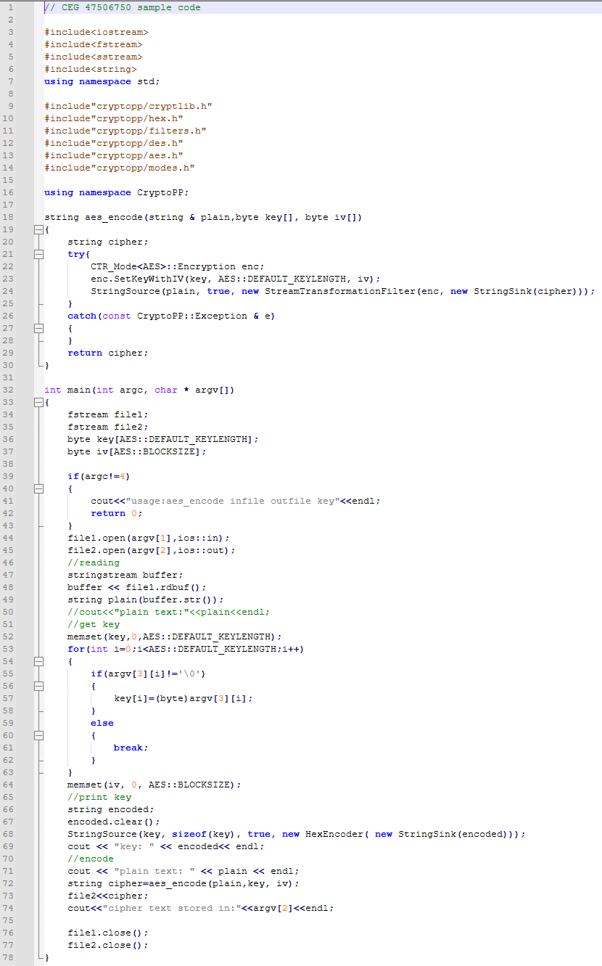
Figure 2.6 – Source code (aes_encode_Counter_SP2026.cpp)
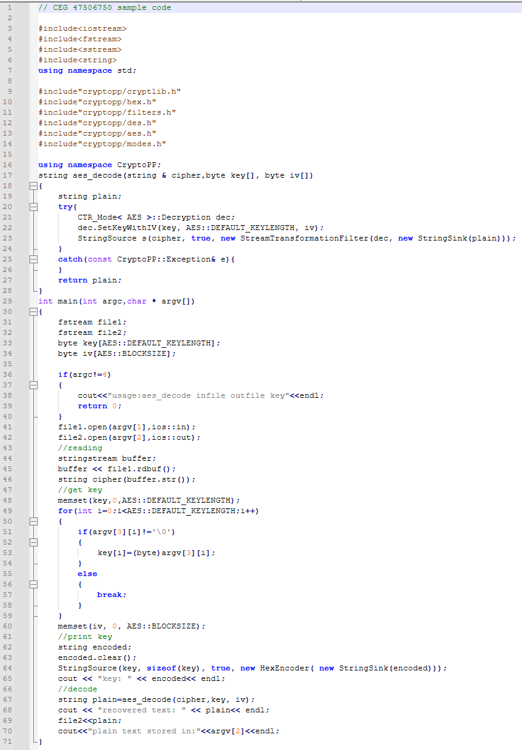
Figure 2.7 – Source code (aes_decode_Counter_SP2026.cpp)

